SE Boot Camp Assignment 5 Youssef Kabbouch

Part A. After creating 5 tables and inserting all data (with syntax provided), Run below query and show the result

select count(*) from actors

union all

select count(*) from directors

union all

select count(*) from movies

union all

select count(*) from movie_revenues

union all

select count(*) from movies_actors

Part B. Run below 4 queries and show the result

1. select movie_name,release_date from movies

|  |
| --- |
|  |

2. select first_name,last_name from directors where nationality='American'

|  |
| --- |
|  |

3. select * from actors where gender='M' AND date_of_birth>'1970-01-01'

4. select movie_name from movies where movie_length>90 and movie_lang='English'

|  |
| --- |
|  |

Part C. Run below 3 queries and show the result

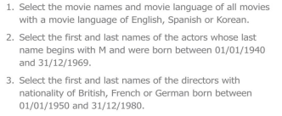

1. select movie_name,movie_lang from movies where movie_lang in('English','Spanish','Korean')

|  |
| --- |
|  |

2. select * from actors where first_name LIKE 'M%' and date_of_birth between '1940-01-01' and '1969-12-31'

3. select first_name,last_name from directors where nationality in('British','French','German')and date_of_birth between '1950-01-01' and '1980-12-31'

